Raley's Mobile Asthma Screenings 2016 Sites

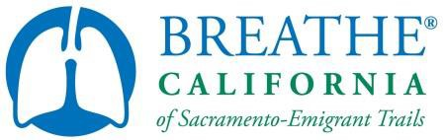

|  |  |  |
| --- | --- | --- |
| **Pharmacy Name** | **Address** | **Screening Date** |
| Raley's Pharmacy #206 | 367 West Main Street Woodland, CA 95695 | Wed, May 18th 1:00-3:00pm |
| Raley's Pharmacy #306 | 4255 E. Morada Lane Stockton, CA 95212 | Tues, May 10th 4:00-6:00pm |
| Raley's Pharmacy #319 | 217 Soscol Avenue  Napa, CA 94559 | Sat, May 21st 1:00-3:00pm |
| Raley's Pharmacy #405 | 4850 Freeport Boulevard  Sacramento, CA 95822 | Thur, May 26th 1:00-3:00pm |
| Raley's Pharmacy #417 | 4840 San Juan Avenue Fair Oaks, CA 95628 | Mon, May 23rd 1:00-3:00pm |
| Raley's Pharmacy #426 | 781 South Highway 49  Jackson, CA 95642 | Wed, June 1st 11:30am-1:30pm |
| Raley's Pharmacy #448 | 1601 West Capitol Avenue West Sacramento, CA 95691 | Sat, June 4th 2:00-4:00pm |
| Bel Air Pharmacy #510 | 1540 West El Camino Avenue Sacramento, CA 95833 | Mon, June 6th 3:00-5:00pm |
| Bel Air Pharmacy #517 | 2222 Grass Valley Highway Auburn, CA 95603 | Fri, June 10th 4:00-6:00pm |
| Bel Air Pharmacy #524 | 2760 East Bidwell Street Folsom, CA 95630 | Mon, June 13th 4:00-6:00pm |